One-Way ANOVA – Example 2 (Alternative Treatments for Depression)
There have been a wide variety of treatments for depression over the years, many of which would be considered alternative treatments. A group of participants who suffered from mild depression each participated in one of the following conditions. Each score represents the level of depression reported following a 6-week program of relaxation, acupuncture, yoga, or weight training. Analyze the data using the appropriate statistical test.

Step 1. State your hypotheses.
a. Research hypotheses
H_{A}:

H₀:

b. Statistical hypotheses
H_{A}:

H₀:

Step 2. Set the significance level ➔ α = .05 Determine F_{crit}. F_{crit} = _________
df_{between} = ________ df_{within} = ________

df_{between} = k – 1 df_{within} = N_{tot} – k df_{tot} = N_{tot} – 1 df_{tot} = df_{between} + df_{within}

Step 3. Select and compute the appropriate statistic and then complete the source table.
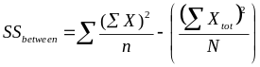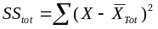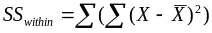
Relaxation  X₁ | Acupuncture  X₂ | Yoga  X₃ | Weights  X₄
4 | 3 | 2 | 1
5 | 7 | 9 | 3
8 | 9 | 3 | 4
10 | 4 | 6 | 3
ΣX₁ = | ΣX₂ = | ΣX₃ = | Σ X₄=
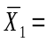 | 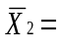 | 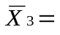 | 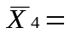

MS_{between} = SS_{between} / df_{between} MS_{within} = SS_{within} / df_{within} 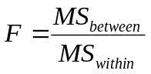

Source | SS | df | MS | F
Between
Within
Total

Step 4. Make a decision. Determine whether the value of the test statistic is in the critical region. Draw a picture. Label F_{crit} and F_{obt}. Is F_{obt} in the critical region? ___________

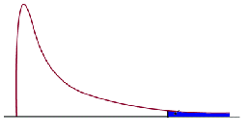

Step 5. Report the statistical results.

Step 6. Write a conclusion.

Step 7. Compute η² and write a conclusion.
